CLINICAL TRIAGE AND WORKFLOW GUIDELINES FOR THE C‐SSRS

Answers on the C‐SSRS provide the information needed to classify someone’s suicidal ideation and behavior, and when combined with clinical judgment, can help determine levels of risk and aid in making clinical decisions about care.

The C-SSRS has operationalized thresholds for imminent risk. No matter where the Columbia is being used, the imminent risk answers are the same. Those answers are a “yes” to items 4 or 5 for ideation severity (There is intent to act) within the past month or a “yes” to having any behavior in the past 3 months.
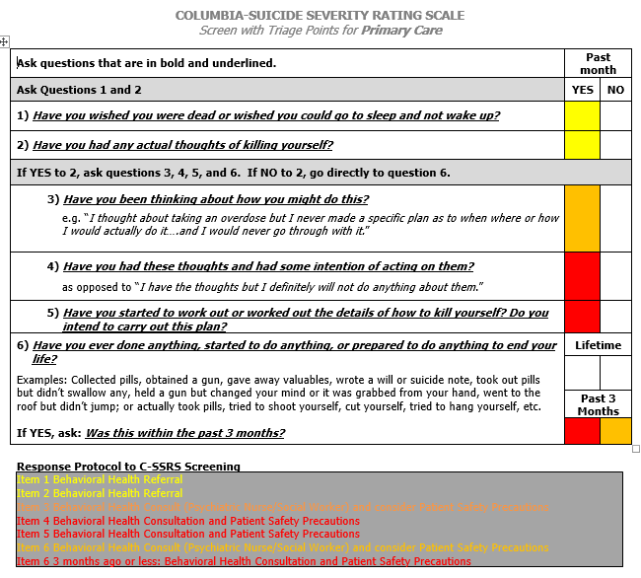
These high-risk answers require patient safety precautions until a mental health professional can evaluate the individual for possible hospitalization. Other answers on the Columbia only require referral to outpatient providers and crisis hotlines
This first level screening can be done by anyone (nurses, teachers, clergy, lawyers, parents, etc.) or by self-report.
Below and attached are some examples of workflow.
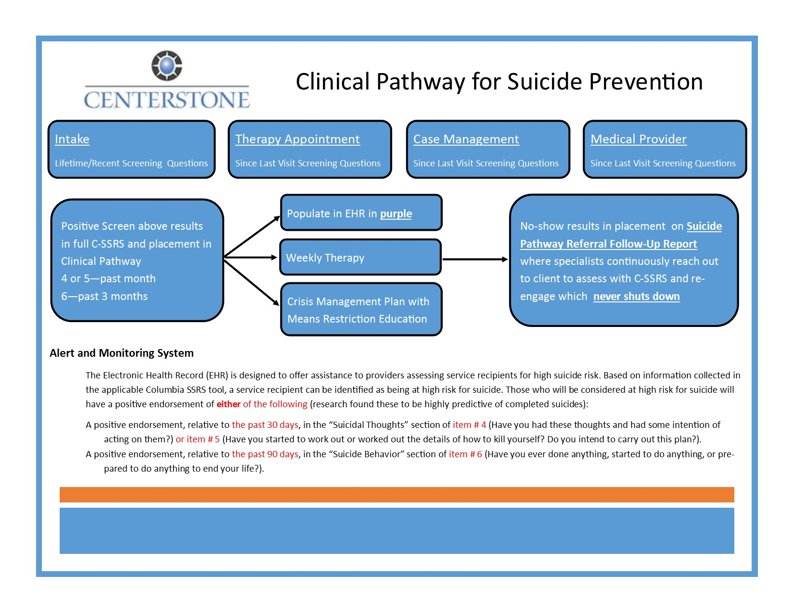
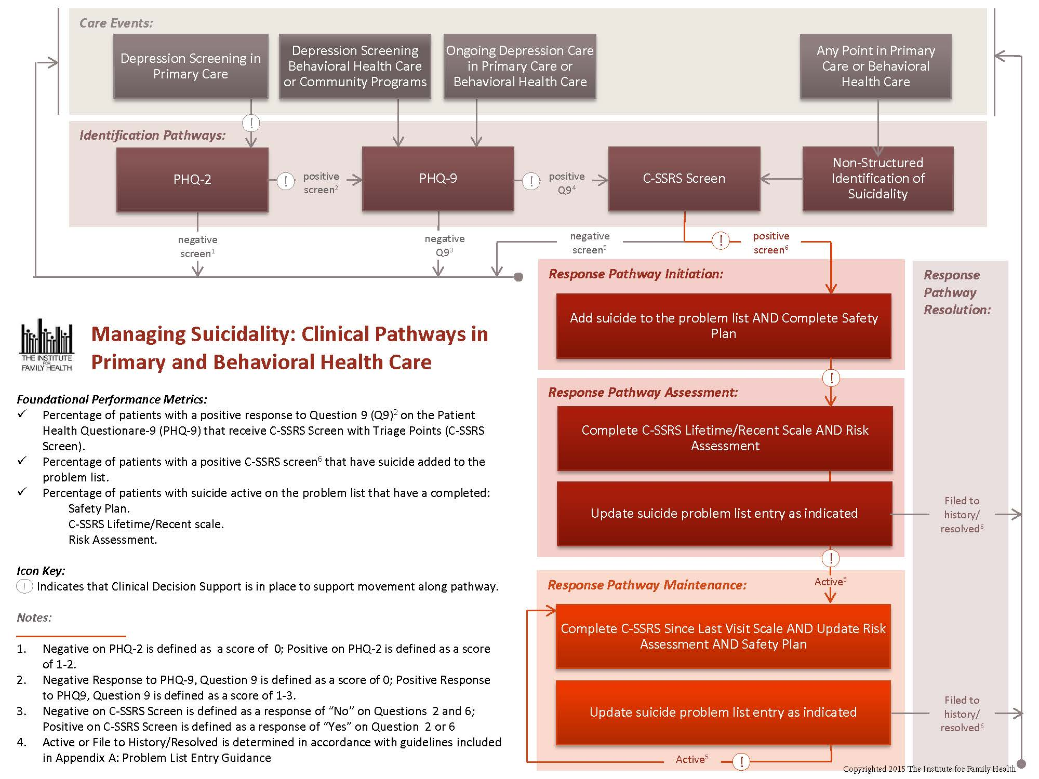
Severity of Ideation Subscale - consists of 5 questions that reflect five types of ideation of increasing severity:

- A positive answer to Question 4 or 5 indicating presence of ideation with at least some intent to die in the past one month indicates a severe risk and clear need for further evaluation and clinical management (e.g., triggers immediate referral to mental health services and patient safety precautions).

4 – Active Suicidal Ideation with Some Intent to Act, Without Specific Plan (e.g., I would hang myself [method] and I can’t guarantee that I won’t do it [intent]).

5 – Active Suicidal Ideation with Specific Plan and Intent (e.g., tomorrow at 1:00pm when I know no one will be home [plan], I am going to [intent] take a handful of Tylenol that I have in my medicine cabinet).

Suicidal Behavior Subscale - includes questions about 4 suicidal behaviors and non‐suicidal self-injurious behavior.

- Presence of ANY suicidal behavior (suicide attempt, interrupted attempt, aborted attempt and preparatory behavior) in the past 3 months indicates a severe risk and clear need for further evaluation and clinical management (e.g., triggers immediate referral to mental health services and patient safety precautions).

*Note: Endorsement of other questions on the scale could also indicate a need for further evaluation or clinical management depending on population or context, however a positive answer to Question 4 or 5 in the past month or any behavior in the past 3 months indicate the most severely emergent clinical situation.

STATE‐WIDE ELECTRONIC MEDICAL RECORD SYSTEM
(used by the New York State Office of Mental Health facilities with outpatient services)

The system automatically adds a RED SUICIDE WARNING ALERT to the patient’s record for endorsing a “4 or 5” in the past month or a behavior in the past 3 months; and an ORANGE SUICIDE HISTORY ALERT if there is any lifetime history of ideation severity of ”4 or 5” or any suicidal behavior.

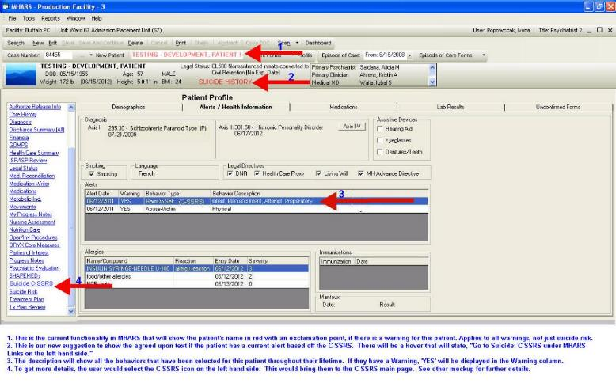
HOSPITAL SETTINGS FOR THE JOINT COMMISSION REQUIREMENT

A Sample Intervention Matrix
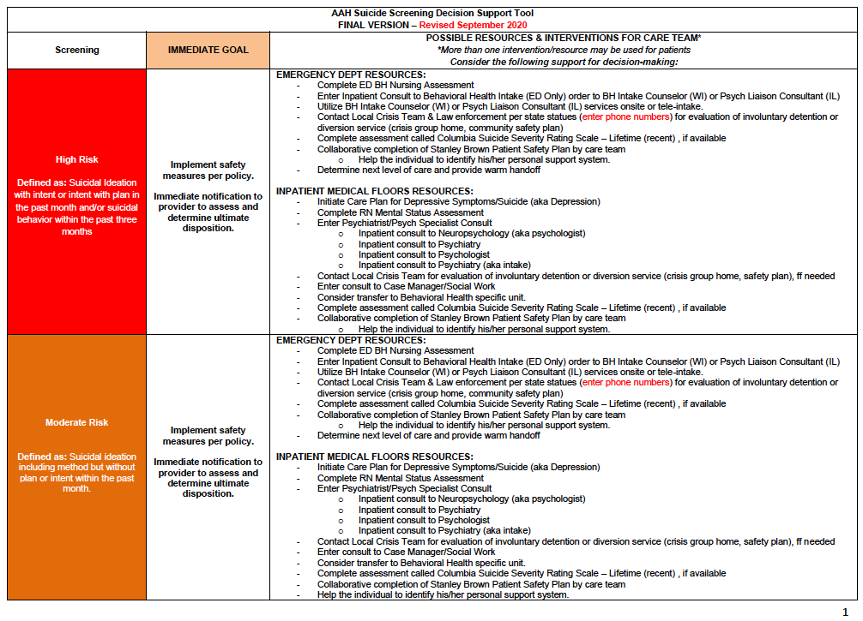

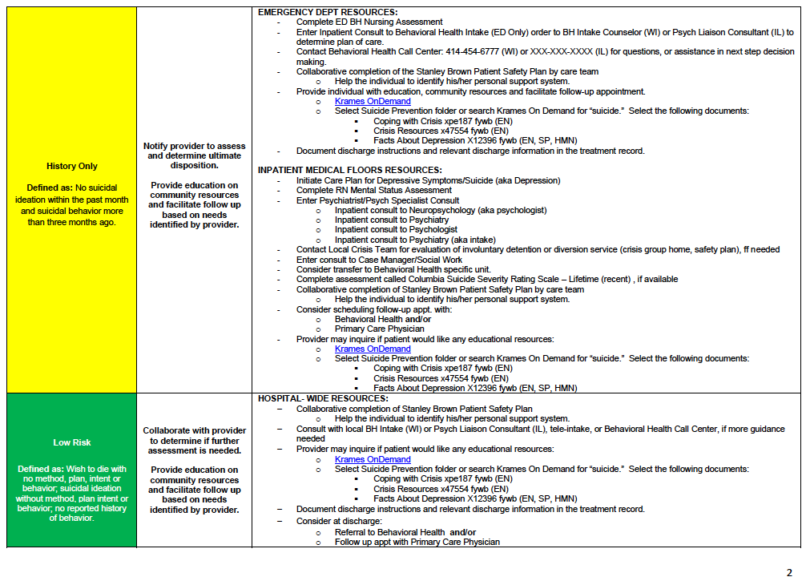

A Sample Intervention Plan

