Columbia Suicide Severity Rating Scale (C-SSRS) Resource Guide

Thank you for choosing to use the paper version of the Columbia Suicide Severity Rating Scale (C-SSRS) in your upcoming clinical trial. This guide contains links for downloading the C-SSRS, instructions on obtaining rater training and certification, and accessing other relevant materials and information through our Dropbox website.

LICENSING THE C-SSRS

This document is intended solely for use in industry-sponsored clinical trials where a C-SSRS license agreement has been obtained or is in process. To initiate the licensing process, please email Dr. Kelly Posner at Kelly.Posner@nyspi.columbia.edu and include the following details in your request:

- Protocol number
- Study phase number
- Protocol title
- Approximate number of C-SSRS administrations (calculated as: expected number of enrolled subjects × number of C-SSRS assessment points in the protocol)

ACCESSING RATING SCALES AND TRANSLATIONS

Under your current or pending C-SSRS license agreement, you have permission to download all C-SSRS versions and available translations through the Scales by Country database on our Dropbox (refer to the screenshot below). You may download as many rating scale versions and translations as required, as well as translation certificates to confirm linguistic validation.

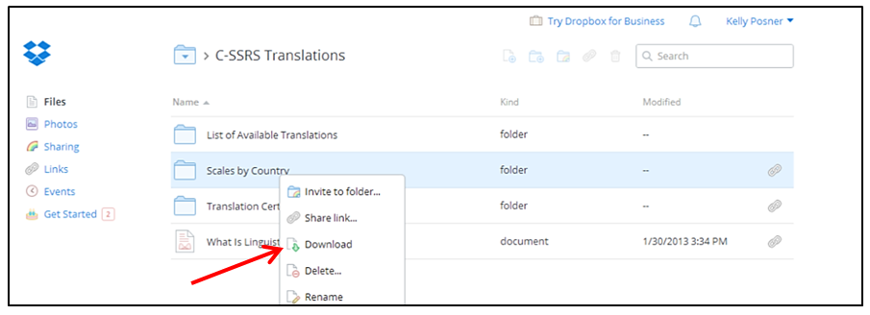
Steps to download entire Translation library:
- Visit the “C-SSRS Translations” page.
- Click on the folder “Scales by Country”.
- Click on the Download in the upper right corner.

The entire library will be downloaded as one zipped file. To unzip the file, double click.

All translations available in the C-SSRS library are the most up-to-date versions. However, because the scale undergoes periodic revisions, some existing translations may not fully reflect the latest content and formatting updates made to the English-language C-SSRS, which serves as the source document for all translations.
We recommend updating these translations through ICON (Mapi), the company responsible for C-SSRS linguistic validation. To validate and certify linguistic modifications, obtain new translations and timelines for their completion, please contact ICON (Mapi) at ICONLSTransRequest@iconplc.com.

To ensure consistent and superior translations of the C-SSRS, we require that ICON (Mapi) manage the linguistic validation process. However, studies may amend the timeframes/recall periods (e.g., adjusting "years" to "months") across different versions of the scale to align with their specific research needs. Prior authorization from the scale developers is not required for these modifications.

RATER TRAINING AND CERTIFICATION REQUIREMENTS

Anyone can administer the C-SSRS, regardless of degree, regardless of degree, provided they view the C-SSRS training and are issued a training certificate. Raters must undergo re-training every 2 years (based on the date on their training certificate), unless they are administering the scale in an ongoing study that exceeds a 2-year time period (e.g., a long-term open-label extension study). Sponsors are responsible for tracking and maintaining training certificates for compliance.

ACCESSING TRAINING

There are three ways to complete the C-SSRS training for a clinical trial:

- BlueCloudX (formerly known as TRAINING CAMPUS)
Web-based training is available on our online 24/7 Training System. To access this training, follow the steps outlined below.

- Log in to the Global BlueCloudX Training System website. First-time users must register.
- Click on "My Activities."
- Under "Available Curricula," select "Enroll Now" for the training module in your preferred language.
- Under "Active Curricula," click on the training module you enrolled in to expand the view, then select the hyperlinked module name to load it.
- After watching the training video, close the window and complete the case study questions to receive an auditable certificate by clicking on the green arrow to proceed.

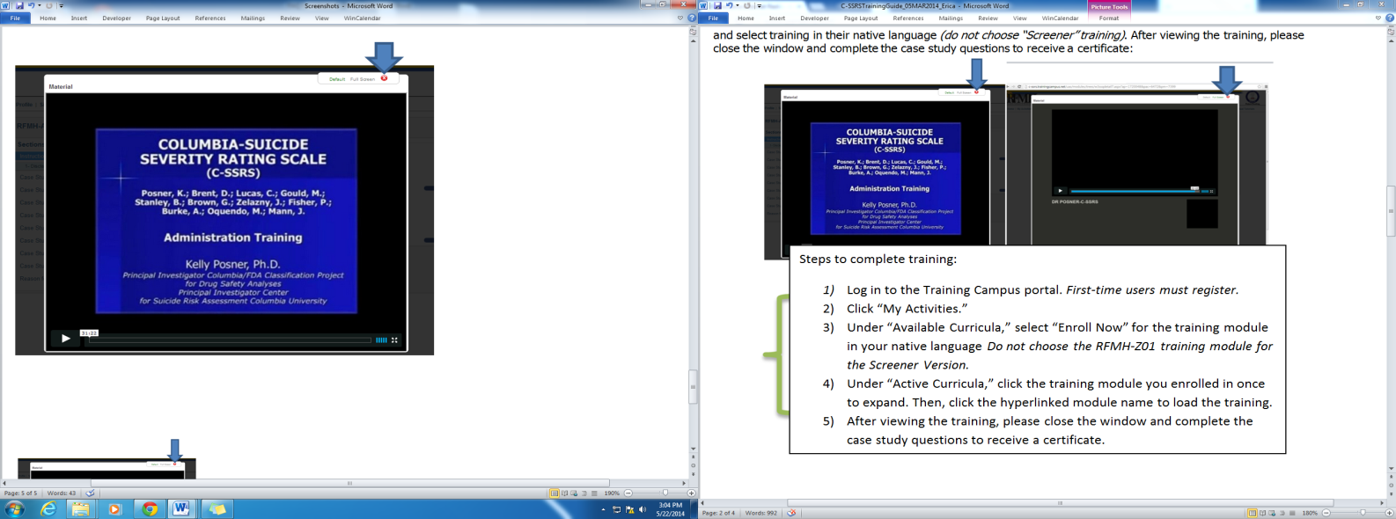 | 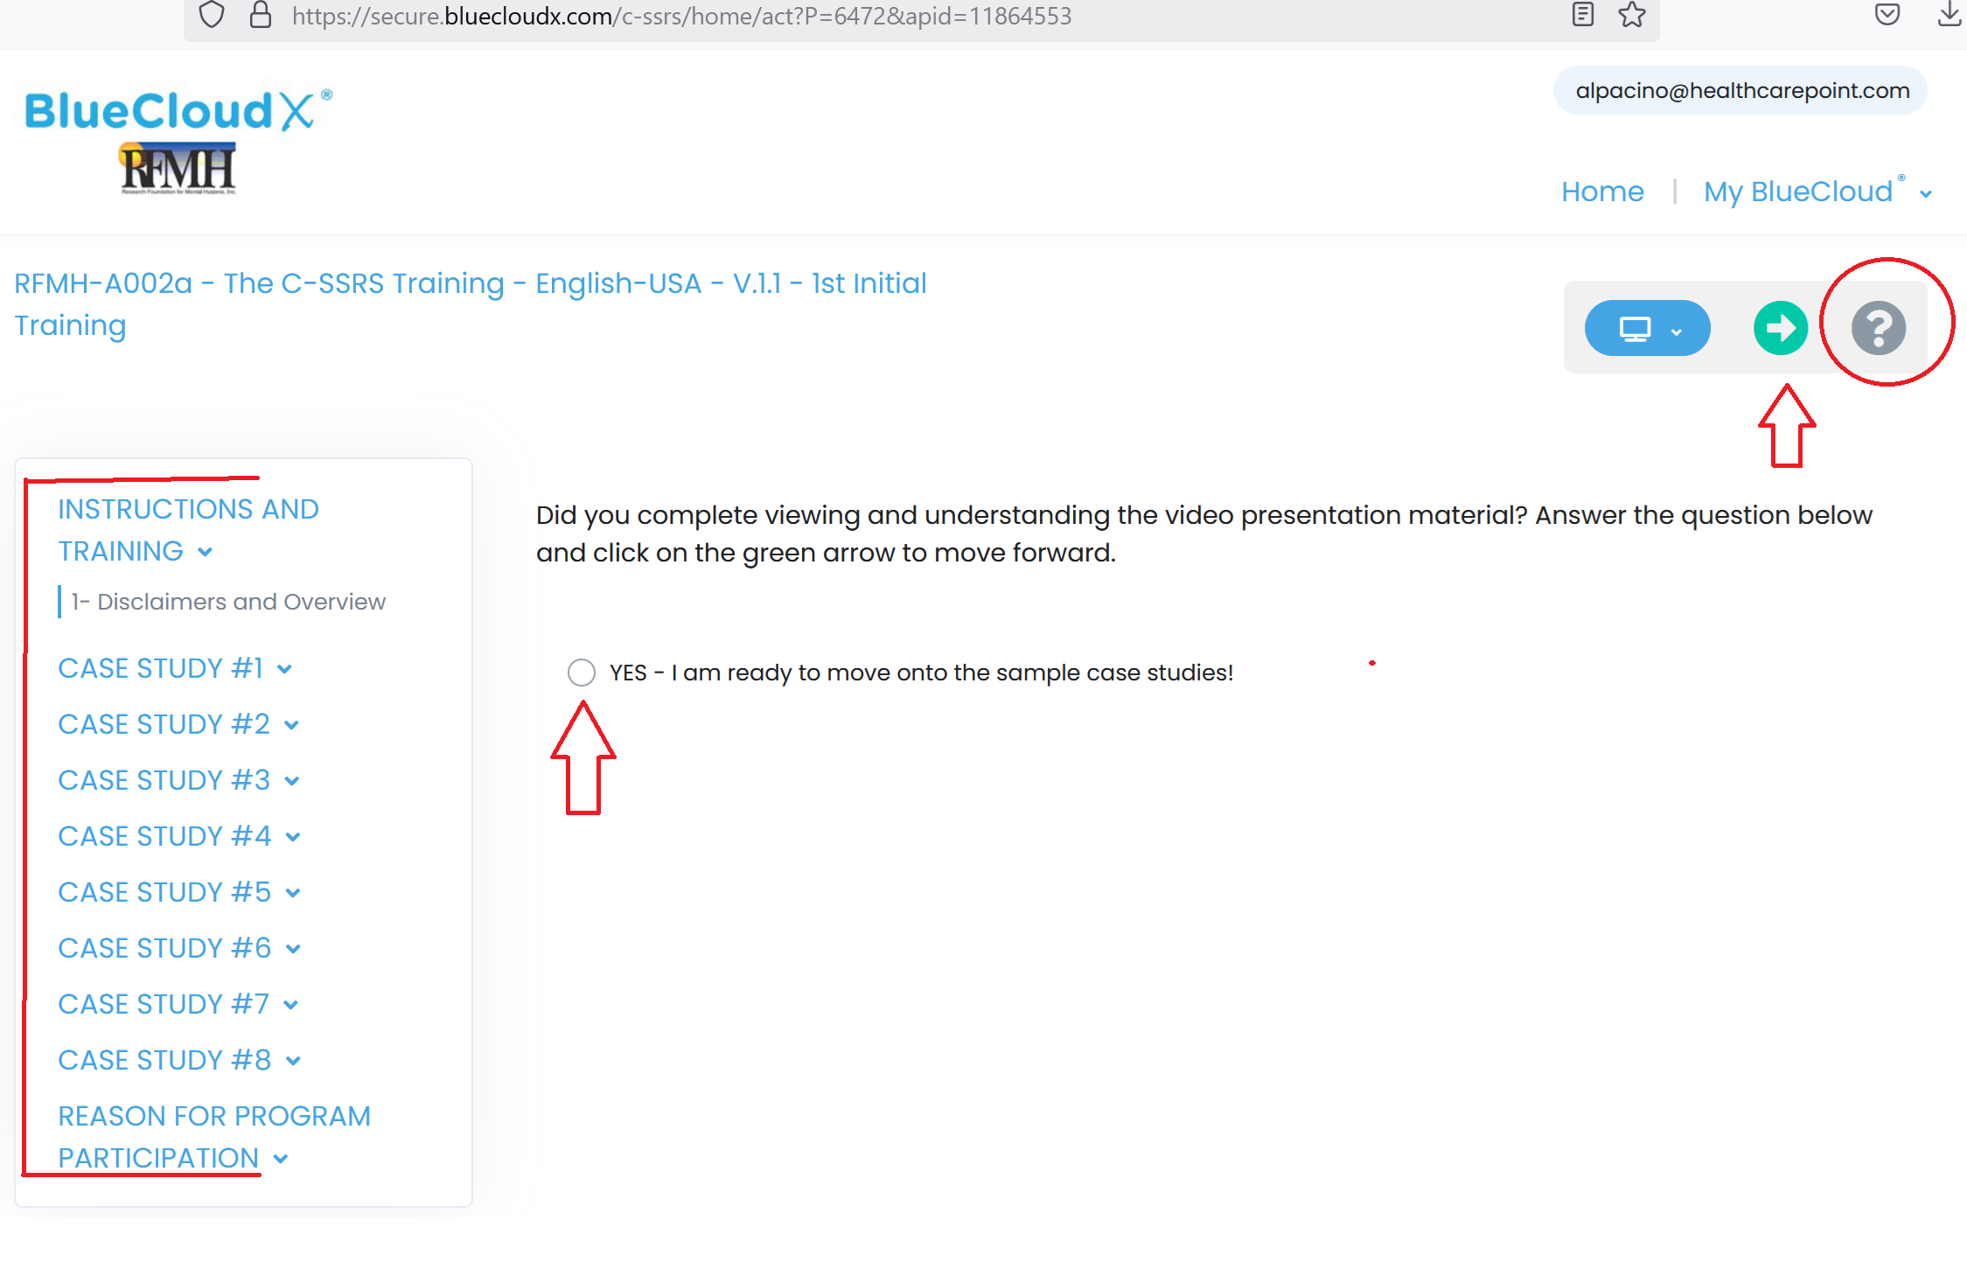

- Ensure you follow all instructions carefully to obtain an auditable e-certificate.
- Always click the green arrow to move forward.
- Click on the “?” for additional instructions.

Important Notes
🚨 Browser Compatibility: The BlueCloudX may not work properly with some versions of Internet Explorer. Please use Firefox or Google Chrome if you experience difficulties.
💡 Need Assistance? Contact the BlueCloudX Customer Support at Support@BlueCloudX.com or call the Support Desk at 512-302-3113.
📌 Audit-Ready Program: If your organization requires an efficient system to reconcile auditable/audit-ready training certificates, please contact Support@BlueCloudX.com for more details.
📌 Documenting Standardized Processes for FDA, EMA & Other Auditing Agencies (Sites and Sponsors): You can download a FREE Standard Operating Procedure (SOP) for your local regulatory files at BlueCloudX Industry Standards.

- DOWNLOADABLE VIDEOS ON DROPBOX:
The training videos are available in many languages and may be copied to flash drives and DVDs. The number of downloads is unlimited for each study covered under the license agreement. To download a training video, please the instructions below.
- Visit our training video library.
- Select a language-specific training folder.
- Select the image of the training video in the language you want.
- Click on the Download button in the upper right corner to save the file to watch on your device. For a short preview, click on the image of the video.
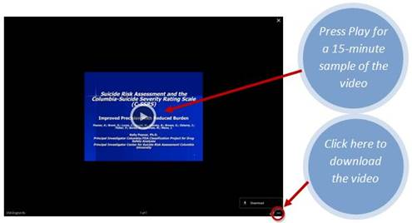
NOTE: If you are experiencing trouble playing media files, please download VLC player at: www.videolan.org/vlc

- DVD Option:
Parties that cannot conduct internet-based training or have restrictions on sharing electronic files may contact us to obtain one training DVD per language.
- Provide your name, mailing address and country, phone number, and the desired training language(s).
- For shipments within the United States allow 3 business days, and 7 days for shipments outside of the United States.

SUBTITLED TRAINING VIDEO IS AVAILABLE IN THE FOLLOWING LANGUAGES

Afrikaans | Arabic | Bulgarian | Croatian | Czech | Danish | Dutch | English | Estonian | Finnish | French | German | Greek| Hebrew | Hungarian | Italian | Japanese | Korean | Latvian | Lithuanian | Malay | Mandarin | Polish | Portuguese | Romanian | Russian | Serbian | Slovak | Spanish | Swedish | Traditional Chinese | Turkish

Please contact us if you would like a transcript or a Power Point presentation version of the training.

TRAINING CERTIFICATE CAN BE OBTAINED IN 2 WAYS

- BlueCloudX generates a personalized certificate at the end of the training session, which can be accessed at any time.
- For training that was completed using a downloaded video or DVD, raters may visit the Global BlueCloudX Training System website to complete a self-assessment and obtain a certificate.
  - Select the training module in your preferred language.
  - Skip the training video by closing the window and then complete the case study questions.

- Training Technical Support: If you encounter any difficulties with printing or retrieving the training certificate, please contact the BlueCloudX customer support at support@BlueCloudX.com or call the Support Desk at 512-302-3113 for immediate assistance.

Additional questions should be directed to Kelly.Posner@nyspi.columbia.edu.

